EAST PROVIDENCE SCHOOL DEPARTMENT

EDUCATION REFORM

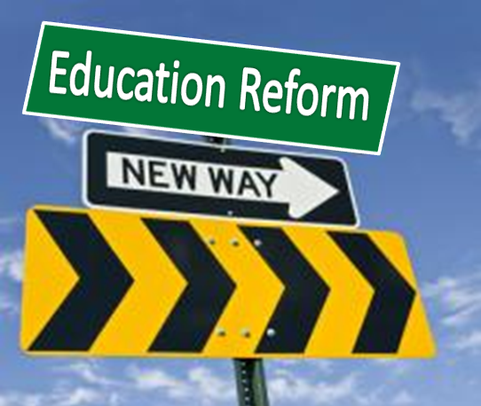

Presented by: Benjamin M. Scungio, Esq.



